EXPERIMENT—5 1

Setup

You will need:

• Docker installed on your machine.

• A simple HTML file for the app.

2. Step 1: Create the HTML File Create a directory for your HTML app and place an index.html file in it.

mkdir nginx-html-app

cd nginx-html-app

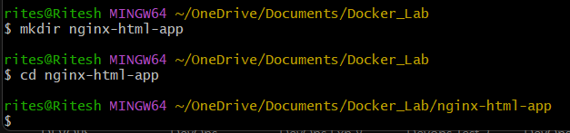

Inside the nginx-html-app directory, create the HTML file.

touch index.html



<!DOCTYPE html>

<html lang="en">

<head>

    <meta charset="UTF-8">

    <meta name="viewport" content="width=device-width, initial-scale=1.0">

    <title>Docker </title>

</head>

<body>

    <h1>Welcome To My Nginx App</h1>

    <p>This is a simple HTML app served by Nginx in a Docker Container</p>

</body>

</html>

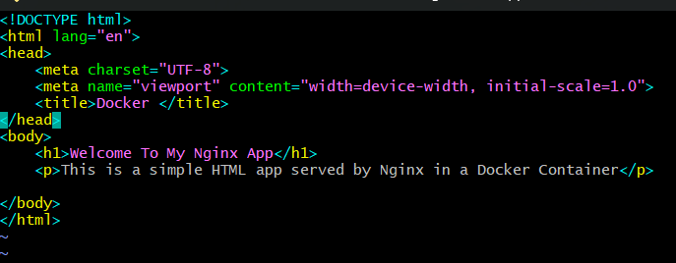

3. Step 2:Create a Dockerfile

In the same directory, create a Dockerfile. This file will define how to build the Docker image using Nginx as the base image .

touch Dockerfile

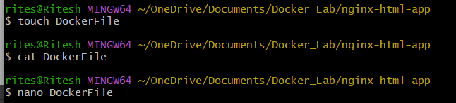

Edit the Dockerfile and add the following content:

FROM nginx:latest

COPY index.html /usr/share/nginx/html/

EXPOSE

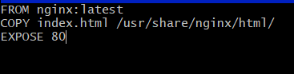

4. Step 3: Build the Docker Image

Now that you have the Dockerfile and index.html, it’s time to build the Docker image. Run the following command to build the image, giving it a tag (e.g., nginx-html-app):

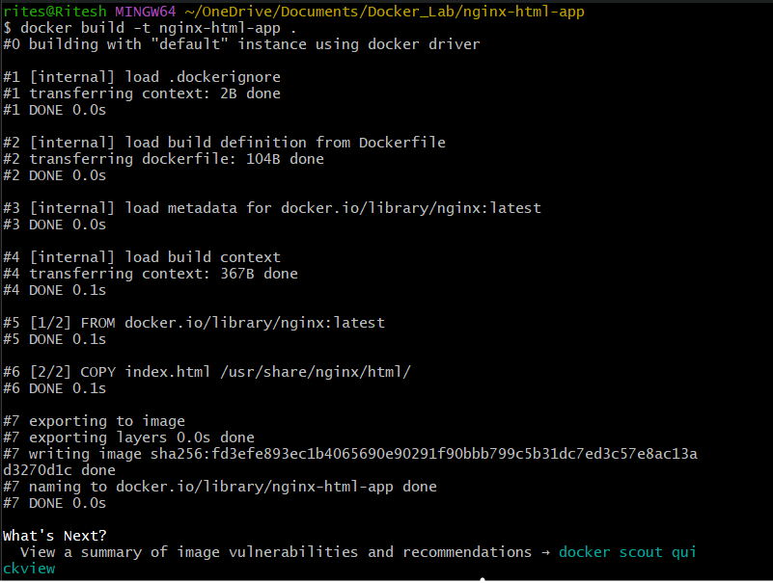

Docker will use the Nginx base image, copy your index.html into the appropriate directory, and build the image.

5. Step 4: Run the Docker Container

After building the image, you can run the container with the following command:



This command runs the container in detached mode (-d) and maps port 8080 on your host machine to port 80 inside the container, where Nginx is serving your HTML app.

6. Step 5: Verify

Open a browser and go to http://localhost:8080. You should see your HTML page with the message “Hello, Nginx Docker!”.

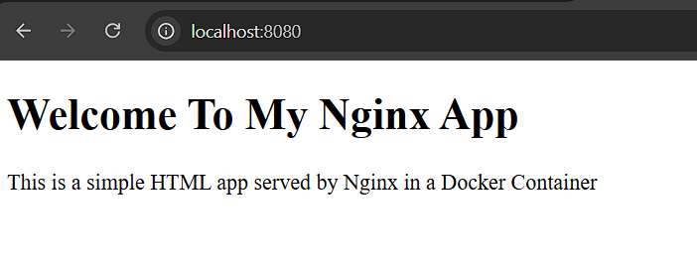

7. Step 6: Stop and Remove the Container

Once you're done, you can stop and remove the container:

docker ps # to see running containers

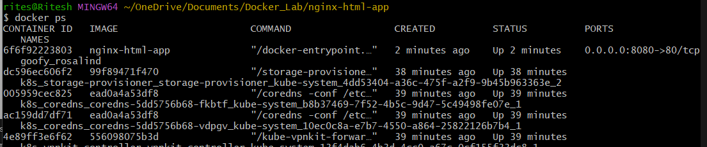

docker stop <container-id>

docker rm <container-id>

